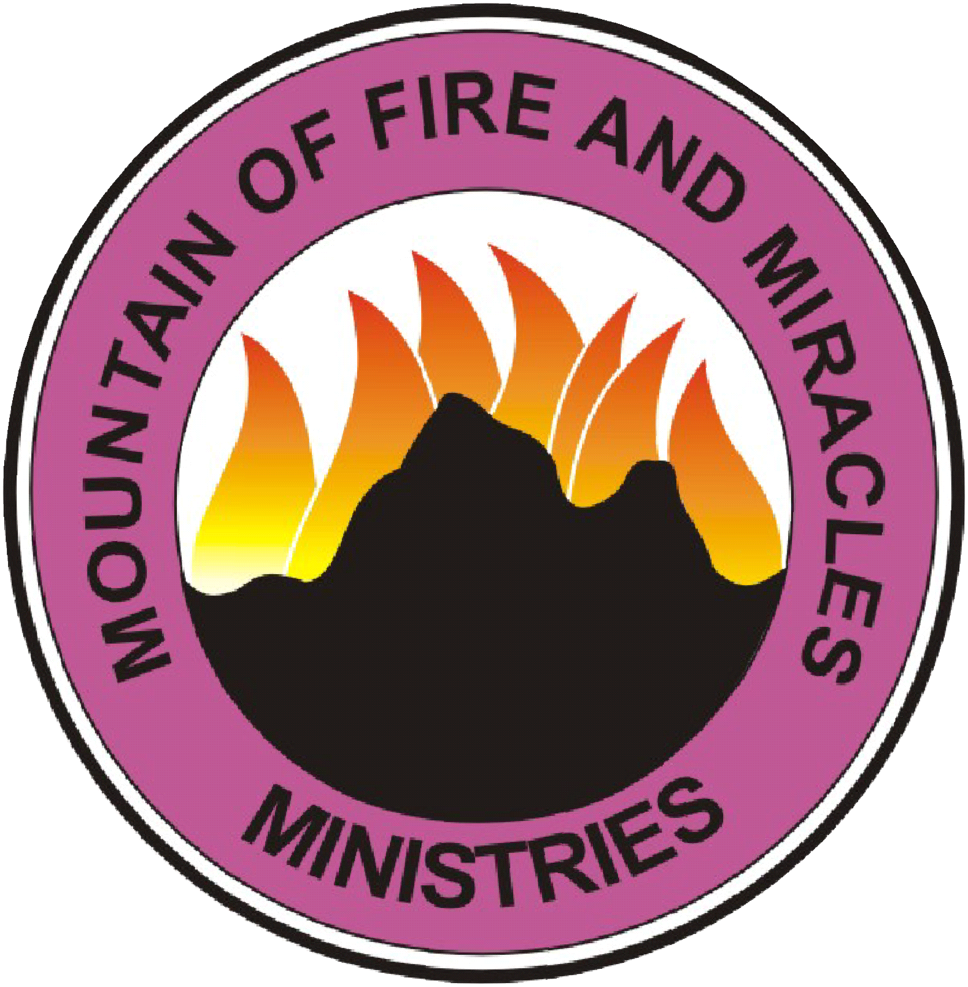
MOUNTAIN OF FIRE & MIRACLES MINISTRIES
Providence Pavilion of Praise RI

PROSPERITY FOR YOUR MARRIAGE
PRAYER POINTS

1. This session is titled: PARALYZING MARRIAGE KILLERS:
1. All counsels against my marital life, collapse, in Jesus' name.
2. Any association between my husband/wife and any strange man\woman be scattered now, in Jesus name.
3. Every demonic in-law, loose your hold upon my life, in Jesus' name.
4. Every curse that has been issued against my marriage be cancelled in the name of Jesus.
5. Every demonic mark contrary to settled homes be wiped off with the, blood of Jesus.
6. Every inherited spirit that is not of God, go, in the name of Jesus.
7. Every curse issued against my marriage or against my marital life, be broken, in the name of Jesus.

2. This session is titled: ERASING EVIL ANTI- MARRIAGE MARKS:
1. Every anti-marriage curse be broken in the name of Jesus
2. Raise your two hands up
Every evil wedding ring on my finger be removed by fire in the name of Jesus.
3. Every trademark of evil marriage be shaken out off my life in the name of Jesus.
4. I revoke every witchcraft verdict on my marital life in the name of Jesus.
5. O Lord recreate my beauty to attract my God given partner in the name of Jesus.

3. This session is titled: DESTROYING PLANS OF EVIL IN-LAWS:
1. Let every evil architect destroying my marriage amongst my in-laws be exposed and disgraced in Jesus name.
2. I command every evil architect of hatred, hostility, and conflict in my marriage be paralyzed in Jesus name.
3. Oh Lord, arise and disgrace every power challenging my marriage within my in-laws in Jesus name.
4. Let all evil in-laws receive angelic slap after the order of Herod in Jesus name.
5. Let all those despising me in my husband’s house receive divine disgrace today in Jesus.
6. I command all evil transportation system of in-laws to ground to halt and irreparable regret in Jesus

4. This session is titled: POWER OVER TERRITORIAL SPIRIT:
1. I command the territorial spirits controlling me from my place of birth to release me in Jesus name.
2. Father Lord, let your fire be kindled against every shrine in my town working against my life in Jesus name.
3. Oh Lord let the evil priests in my town destroy themselves for my sake in Jesus name.
4. I refuse to answer anymore satanic calling of my name in Jesus name.
5. All territorial weapons fashioned against my marital life will not prosper in Jesus name.
6. Father Lord, I destroy all the troublers of my marriage in my home in Jesus name.
7. Let all worshippers of idols prepared against my marriage die in Jesus name.

5. This session is titled: PRAYER AGAINST EVIL COUNSELORS:
1. Father Lord let all evil counselors in the life of my husband be disgraced to death in Jesus name.
2. I command all evil counselors attached to my matrimonial life to die after the order of Ahithophel in Jesus name.
3. Lord Jesus let your name and power paralyze all the activities of evil counselors in Jesus name.
4. I command blankness of mind to envelop all satanic counselors attached to my marriage in Jesus name.
5. Father Lord, release abundantly upon the heads of all evil counselors your fire and brimstone in Jesus name.
6. I command the wrath and anger of God to fall upon the evil counselors in my marriage in Jesus name.
7. You evil counselors in my husband’s life stumble, fall, die and be roasted in Jesus name.
8. You strongman of evil counsel release my marriage and my husband\wife in Jesus name.

6. This session is titled: PARALYZING THE ACTIVITIES OF STRANGE WOMEN/MEN:
1. I plunder every habitation of strange women/men and render it desolate in the name of Jesus.
2. You strange powers from the bottom of river, under rock, under evil trees and graveyard fashioned against my marriage be roasted in Jesus name.
3. I command every activity of strange women/men in the life of my husband/wife to cease immediately now in Jesus name.
4. Father Lord, shied my married from evil sun shinning by the day and evil moon of the night in Jesus name.
5. You son of the strange woman/man you will not shine upon my marriage in Jesus name.
6. You moon of the strange woman/man you will not locate my marriage in Jesus mighty name.
7. I command every strange leg in my marriage, my life and husband/wife’s life to walk out now in the mighty name of Jesus.
8. I release myself from the cage of spiritual husband/wife in Jesus name.

7. This session is titled: CANCELING ALL DIVORCE SUITS:
1. Oh Lord, thou art the most righteous judge let the divorce suit filed by my husband be handle by the Holy Ghost in Jesus name.
2. Father Lord, I refuse to be separated from my husband in the name of Jesus.
3. Father Lord, fault all the excuses advanced by my husband to advance Your favor upon my life in Jesus mighty name.
4. I withdraw the divorce suit from the hands of satanic agents unto the hand of the Holy Spirit in the name of Jesus.
5. Father Lord depose every human agent of the enemy appointed to put asunder my marriage in Jesus name.
6. Rock of ages, let Your hammer break into pieces all the seats arranged by the devil for the judgment of the case in Jesus name.
7. Father Lord, reverse the divorce suit into a new wedding with my husband in Jesus name.
8. Father Lord, let all the powers supporting the separation be devoured by the Lion of Judah in Jesus name.

8. This session is titled: Defeating the Powers Of Darkness Over Your Marriage:
1. Every demonic sacrifice offered against me and my marriage, be disgraced in Jesus name.
2. Let every satanic oracle directed against my matrimonial home be disgraced in the name of Jesus.
3. O Lord, let blindness and deafness fall upon the raging of the enemy against my home in the name of Jesus.
4. Father Lord, convert all evil powers against my marriage to shaft and blow them away with your own tempest.
5. You spirit and power of marriage destruction, release my marriage in the name of Jesus.
6. Any power fuelling conflicts and hostility in my home, I paralyze you in the name of Jesus.
7. Every program and plans of home wreckers against my marriage, I cancel you in the name of Jesus.
8. Let the blood of Jesus remove any unprogressive label from every aspect of my marriage in the name of Jesus.
9. Let all circles of marital problems break, in the name of Jesus.

9. This session is titled: DEFEATING THE SPIRIT OF POLYGAMY:
1. Let every problem connected to polygamy in my life be nullified by the blood of Jesus.
2. Every power fueling polygamy activities in my marriage fall down and die in the name of Jesus.
3. Fire of God, destroy every habitations of the spirit of polygamy in my life and in the life of my partner.
4. Every polygamous plantation in my marriage, in my life, in the life of my partner, come out with all your root.
5. Let all the affairs of my marriage be withdrawn from evil marital records, evil observer and evil monitors.
6. Let all past evil ancestral activities affecting my marriage negatively be changed to blessings in the name of Jesus.
7. Fingers of the living God, begin to fight on my behalf in every affairs of my life in the name of Jesus.
8. O Lord, destroy every traces of polygamous influence in the life of my … in the name of Jesus.

10. This session is titled: DELIVERANCE FROM EVIL MARITAL INHERITANCE:
1. Any satanic design in my family, receive the fire of God and be roasted in the name of Jesus.
2. Every evil marital re-occurrence in my family back to the 10th generations, I reject your presence in my marriage.
3. Let the power in the blood of Jesus separate me from the hidden curses operating in my family circle.
4. Let every evil inherited marital spirits in my life/in my marriage, go down to the pit in the name of Jesus.
5. I turn back from evil inherited marital journey that I have embarked upon in the mighty name of Jesus.
6. Any evil vessel in my life and my marriage representing evil inherited marital spirit perish without mercy.
7. Every evil inherited marital arrow presently working in my life come out with all your poisons and go down to the pit.
8. I break every bondage of inherited marital failure upon my life and upon my marriage in the name of Jesus.
9. Every strongman representing me in the register of inherited marital bondage fall down and die in Jesus name.

11. This session is titled: DELIVERANCE FROM STRANGE CHILDREN:
1. Let the habitation of strange children be desolate by the Holy Ghost fire in the name of Jesus.
2. Any spirit or power manipulating spiritual children in my dream, die with your strange children in Jesus name.
3. Every ancestral strange children transferred to me, I reject you by fire in the name of Jesus.
4. Every strange children working against my earthly children, die by fire in the name of Jesus.
5. You my eyes, be purged by the Blood of Jesus and refuse to see strange children anymore in Jesus name.

12. This session is titled: JUDGE THE ENEMY OF YOUR MARRIAGE:
1. Father Lord, let all giants standing against peace and unity in my marriage fall down and die now in Jesus name.
2. Let all powers encamping against my home become confuse and scattered in the name of Jesus.
3. Let every power of the oppressors in my marriage rise up against each other in the name of Jesus.
4. Lord Jesus, let your power work mightily in every difficulty situations in my marriage in the name of Jesus.
5. I bind you the strongman working against me in the heart of my husband/wife and all his/her relatives in the name of Jesus.
6. I command the arrows of the strongman working in my family to be roasted completely in the name of Jesus.
7. Let all the troublers of my marriage be disbanded and be confused in the name of Jesus.
8. Let the blood of Jesus cleanse off every unprofitable and evil label in every department of my life in Jesus name.
9. I paralyze all marriage destroyers and anti marriage forces in the name of Jesus.

13. This session is titled: UNSEATING THE NIGHT RAIDERS
1. Every seat of witchcraft in my family / marriage / house be unseated by fire in the name of Jesus.
2. Let every path-way of witchcraft into my life be overturned by the blood of Jesus in the name of Jesus.
3. Every stubborn cause of failure in my life I bury and destroyed you by fire in the name of Jesus.
4. Any member of my family empowering external enemies, die by thunder in the name of Jesus.
5. You family foundational bondage affecting and disgracing my life, I terminate and destroy your activities by the blood of Jesus in the name of Jesus.
6. You evil foundational bondage connecting my life to internal and external destruction, be consumed by fire in Jesus name.

14. This session is titled: WORKING AGAINST STUBBORN SITUATION IN MARRIAGE
1. Let my vision and my tempt be clear towards my marriage in Jesus’ name
2. Every household evil traders trading with my marriage be bound and be roasted by fire.
3. Every arm of evil re-enforcement in my marriage be a scattered by fire of God and be roasted in Jesus’ name.
4. I refuse, frustrate and destroy enemy re-establishment of my evil covenants in marriage.
5. Let God arise with anger and jealously over my unprofitable lateness in marriage.
6. I decree enough is enough of my unprofitable lateness in marriage.
7. I destroy all my evil monitoring gadgets on my marriage.
8. Let my wasters and my delayers in marriage be found no more after the order of Pharaoh.
9. I declare my ways open to victory over marriage in Jesus’ name.
10. I refuse to cry in vain over my marriage in Jesus name.
11. Lord Jesus rent your heavens and deliver me to my husband and my husband to me in Jesus’ name.
12. Let the good testimony of my marriage come forth in Jesus’ name.

